**Advance Naïve Bayes**

[1.9. Naive Bayes — scikit-learn 1.3.0 documentation](https://scikit-learn.org/stable/modules/naive_bayes.html)

<https://scikit-learn.org/stable/modules/naive_bayes.html>

Topics Covered

1. Types of Naïve Bayes
2. Log Probability
3. Laplace Smoothing

Log Probability: Numerical Stability

***Underflow:***

*Jo Early Programmers theah unka sbhse bada Problem kya tha ki*

*Is to Represent Decimals in Memory*

*Computers uses Binary to Store things*

*Binary use karke Decimal ko store krna is challenging*

*Underflow is a condition that can occur in computing when a number nears zero and the computer can no longer store it accurately in memory.*

***Ish Problem ko solve krnekeliye 1 Solution aaya***

***Log Probability***

***Jbh khub saari probability hoti hai tou hum uska Log lelete hai***

***Log (ab) = log a + log b***

*Laplace Additive Smoothing*

*Har Probability mai Kuch alpha & n-alpha add*

*krdete hai Hum Numerator & Denominator mai*

*Koi bhi Probability agar by chance Zero horaha tou uskesth 1 Zero addition krlo for safety*

***We Do this because of Bias & Variance Trade off***

***( Gaussian Naïve Bayes Choddke Sbh mai Alpha hota hai )***

***Inshort***

*Laplace Additive Smoothing Hum isliye use krte hai ki kbhi kbhi Probability 0 hojati hai , ushse pura number 0 hojayega so that’s why hum Alpha & n-alpha add krte hai*

***We add both lyk this because humme flexibility millrahi hai***

***To control bias & variance***

***Alpha High Leads to High Bias or Underfitting***

***Alpha Low or Zero Leads to High Variance or Overfitting***

***Alpha jo hai Hyperparameter hai***

***Jishe hum Tune karke Underfitting & overfitting se bacha sakte hai***

*Laplace Additive Smoothing*

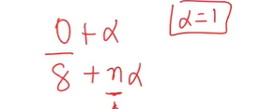 ***n alpha sbhka alag alag rehta***

1. ***Values ko Zero Honese bachate hai***
2. ***It Becomes Hyper parameter Agar Model overfit krrha tou underfit ke direction mai bhej skte & Underfit krrha tou Overfit ke direction mai bhejsakte***

***Kindoff Swing or knob jaisa hai jo hath mai laggya hai jaise.***

1. ***Alpha Value tune karke Bias & variance tradeoff Solve karsakte hai***
2. ***We got better tuning knob jo Underfiting & Overfitting ko ghataskta hai***

***Types of Naïve Bayes***

1. ***Gaussian Naïve bayes***
2. ***Categorical Naïve Bayes***
3. ***Bernoulli Naïve Bayes***
4. ***Multinomial Naïve Bayes***
5. ***Complement Naïve Bayes***
6. ***Gaussian Naïve bayes***

*Data 🡪 Use it When all Features are Numerical*

*E.g jaise hum check krrhe ki iq 99 kitne bacho ka hai*

*Esa hoskta ki Data mai koi bhi na hoo jiska iq 99 hoo*

*So how to classify it ? so*

*Hum Isme kya krte hai ki Assumption lelete hai*

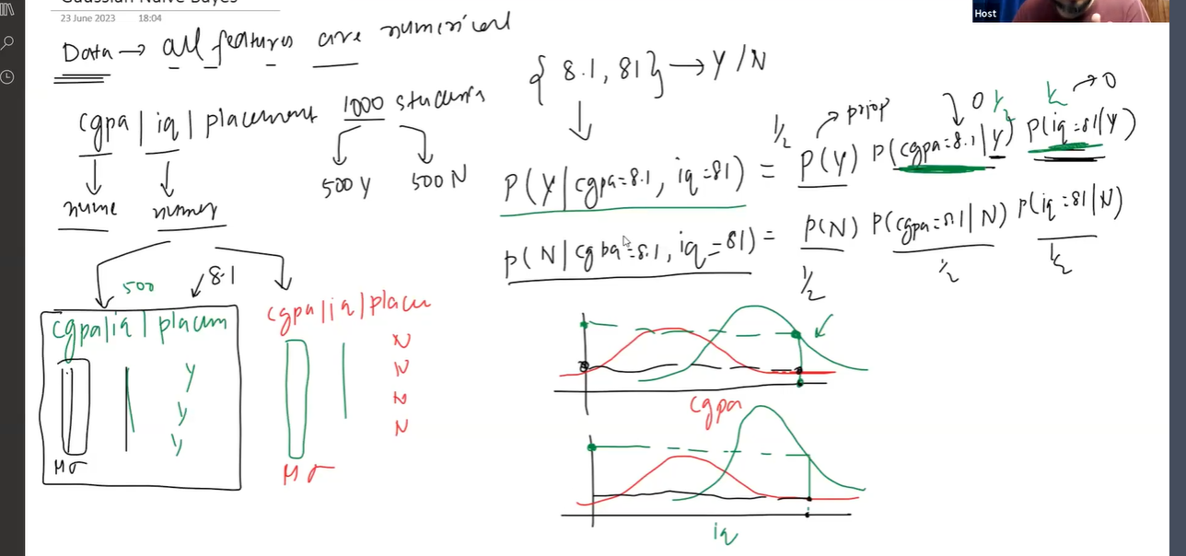

***We only use Gaussian Naïve Bayes when all the input columns are Numerical.***

1. ***Categorical Naïve Bayes***

*Categorical Naïve Bayes is a variant of the Naïve Bayes Algorithm designed specifically to handle categorical data.*

*Isme Hum Laplace Additive Smoothing use karsakte hai*

*When all features are categorical we use Categorical Naïve Bayes*

*Yaha Laplace Additive Smoothing lagaskte hum jaha Conditional Probability lagate hai*

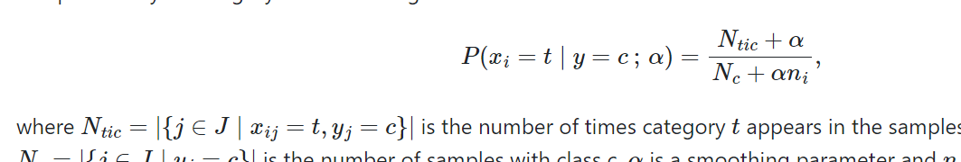

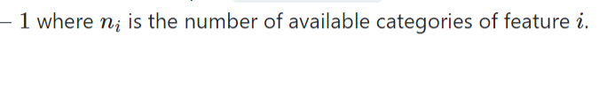

***Multinomial Naïve Bayes***

***Use:***

***If aapke pass esa dataset hai jaha saare features mai discrete values hoo***

***Iska Result: Textual Data mai acha aata hai***

**Advantages**

The Naive Bayes algorithm has the following advantages:

* It is easy to implement as you only have to calculate probability.
* You can use this algorithm on both continuous and discrete data.
* It is simple and can be used for predicting real-time applications.
* It is highly scalable and can easily handle large datasets.

**Disadvantages**

The Naive Bayes algorithm has the following disadvantages:

* The prediction accuracy of this algorithm is lower than the other probability algorithms.
* It is not suitable for regression. Naive Bayes algorithm is only used for textual data classification and cannot be used to predict numeric values.

*Multionominal distribution allow us to calculate the probability of observing a specific count or combination of counts for each category in a fixed number of trials.*

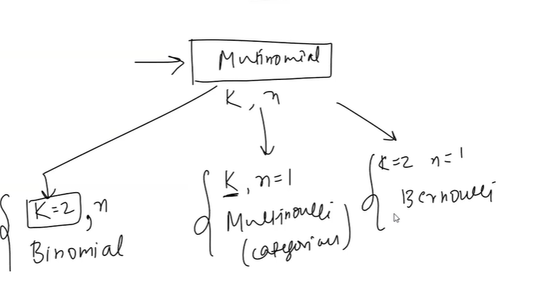

***Multinomial is most generic case***

***Bernoulli Naïve Bayes***

***0 ya 1 , yes or no***

*The Bernoulli Distribution is discrete probability distribution that models the outcomes of a binary random variable*

*The Binomial Distribution is a discrete probability distribution that models the probabilities of different outcomes in a categorical or discrete random variable .*

***Bernoulli Naïve Bayes Implements naïve bayes training & classification algorithm for data that is distributed according to multivariate Bernoulli distributions***

***That is there may be multiple features but each one is assumed to be binary valued variable.***

***Therefore this class requires sample to be represented as binary-valued feature vectors, if handed any other kind of data a BernoulliNaive bayes instance may binarize its input.***

***Bernoulli vo data pe apply hota hai jaha***

***Har feature Bernoulli distribution follow kareah uska mtlb ki bss 2 hie possible outcomes hoo vaha Either 0 ya 1***

***Agar 2 se zyaada hoo tou Bernoulli work nahi karega***

***Multinomial Naïve Bayes***

***Agar saare features are discrete then apply Multinomial naïve bayes even fractions bhi hai tou apply krsakte***

***Better Result Discrete pe aate hai***

***Out of Core Naïve Bayes***

*Bada dataset Load krte jbh tou usme Problem aajati hai*

*E.g*

*3gb ka dataset hai & 2 gb ka ram hai*

*Ese problems ko counter krnekeliye we do*

*Out of Core Naïve Bayes*

*E.g*

*5 GB ka data hai tou*

*10 Chunk mai divide krdo*

*Har 1 chunk 500 MB ka hai*